# Sound Worksheet

## Digitizing an analogue sound

You have been provided with an analogue sound wave which you need to sample. For each point on the graph you should record the sample resolution. You should create a column and shade it in for each measurement taken. The first one has been done for you.

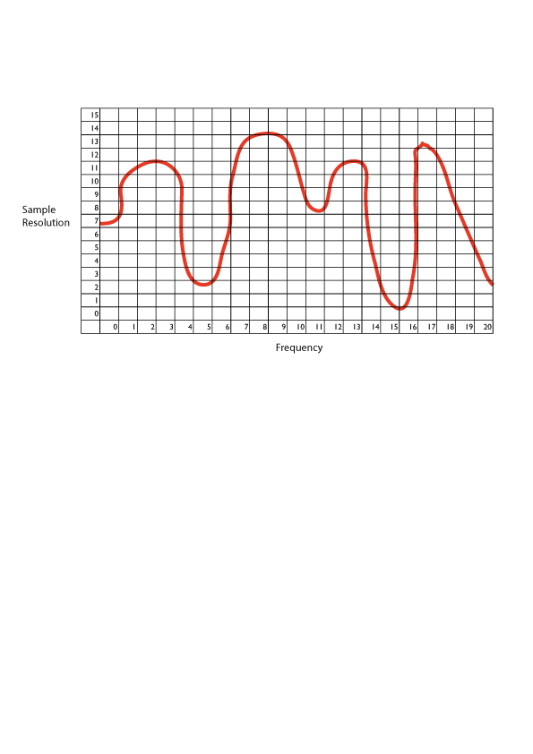

|  |  |  |  |  |  |  |  |  |  |
| --- | --- | --- | --- | --- | --- | --- | --- | --- | --- |
| Time | 0 | 1 | 2 | 3 | 4 | 5 | 6 | 7 | 8 |
| Resolution | 7 |  |  |  |  |  |  |  |  |

|  |  |  |  |  |  |  |  |  |  |
| --- | --- | --- | --- | --- | --- | --- | --- | --- | --- |
| Time | 9 | 10 | 11 | 12 | 13 | 14 | 15 | 16 | 17 |
| Resolution |  |  |  |  |  |  |  |  |  |

|  |  |  |  |
| --- | --- | --- | --- |
| Time | 18 | 19 | 20 |
| Resolution |  |  |  |

## Creating an analogue sound from a digital file

You have been provided with the data below which represents a sound file that is stored on your computer. You should recreate the analogue sound on the grid below.

|  |  |  |  |  |  |  |  |  |  |
| --- | --- | --- | --- | --- | --- | --- | --- | --- | --- |
| Time | 0 | 1 | 2 | 3 | 4 | 5 | 6 | 7 | 8 |
| Resolution | 7 | 14 | 15 | 9 | 4 | 2 | 6 | 7 | 10 |

|  |  |  |  |  |  |  |  |  |  |
| --- | --- | --- | --- | --- | --- | --- | --- | --- | --- |
| Time | 9 | 10 | 11 | 12 | 13 | 14 | 15 | 16 | 17 |
| Resolution | 6 | 8 | 14 | 5 | 1 | 0 | 6 | 8 | 4 |



Sample

Resolution

Frequency